Git Hub : https://github.com/mankumarbhalodiya/Digital-Signal-and-Image-Processing
Q3. (a)
Select any MP3 song of your choice and process it using a low-pass filter that you design. Experiment with at least three different cutoff frequencies and observe how each setting changes the filtered audio output. Discuss your observations in detail, focusing on how the cutoff frequency influences the clarity, tonal balance, and overall character of the song.
Code :
import librosa
import numpy as np
import matplotlib.pyplot as plt
import soundfile as sf
from scipy.signal import butter, sosfiltfilt
filename = "Todh___Prince_Narula___Munawar__Official_Video____Jaymeet___Rony_Ajnali___Gill_Machhrai(128k).mp3"
y, sr = librosa.load(filename, sr=None)
print("Sample Rate:", sr)
print("Duration:", len(y) / sr, "seconds")
def lowpass_filter(data, cutoff, fs, order=6):
sos = butter(order, cutoff, btype="lowpass", fs=fs, output="sos")
return sosfiltfilt(sos, data)
cutoffs = [500, 2000, 5000]
signals = [("Original Music", y)]
for cutoff in cutoffs:
filtered = lowpass_filter(y, cutoff, sr)
sf.write(f"lowpass_{cutoff}Hz.wav", filtered, sr)
signals.append((f"Low-Pass Filter - {cutoff} Hz", filtered))
samples = min(sr // 20, len(y))
time = np.arange(samples) / sr
fig, axes = plt.subplots(4, 2, figsize=(14, 14))
for i, (title, signal) in enumerate(signals):
segment = signal[:samples]
axes[i, 0].plot(time, segment, linewidth=0.8)
axes[i, 0].set_title(title + " - Waveform")
axes[i, 0].set_xlabel("Time (seconds)")
axes[i, 0].set_ylabel("Amplitude")
axes[i, 0].grid(True)
spectrum = np.abs(np.fft.rfft(signal[:min(len(signal), sr * 5)]))
frequencies = np.fft.rfftfreq(
min(len(signal), sr * 5), d=1 / sr
)
spectrum_db = 20 * np.log10(spectrum + 1e-10)
axes[i, 1].plot(frequencies, spectrum_db, linewidth=0.8)
axes[i, 1].set_title(title + " - Frequency Spectrum")
axes[i, 1].set_xlabel("Frequency (Hz)")
axes[i, 1].set_ylabel("Magnitude (dB)")
axes[i, 1].set_xlim(0, 10000)
axes[i, 1].grid(True)
plt.tight_layout()
plt.show()
print("All filtered audio files saved successfully.")
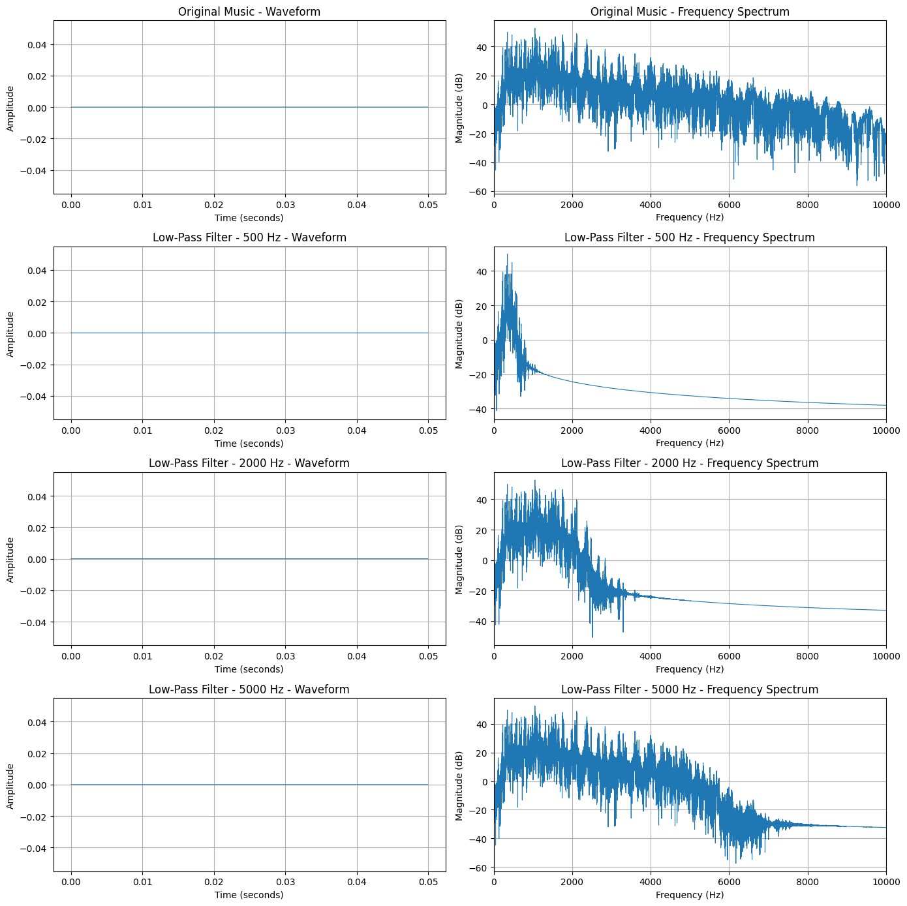
Output :

(b) Use an appropriate band-pass filter to separately suppress vocals and background music, saving each filtered result as its own MP3 file. Analyze and describe your observations, focusing on how each filter affects the different components of the song.
Code :
import librosa
import librosa.display
import numpy as np
import matplotlib.pyplot as plt
import soundfile as sf
from scipy.signal import butter, lfilter
filename = "Todh___Prince_Narula___Munawar__Official_Video____Jaymeet___Rony_Ajnali___Gill_Machhrai(128k).mp3"
y, sr = librosa.load(filename, sr=None)
print(f"Sample rate: {sr}, Duration: {len(y)/sr:.2f} seconds")
def bandpass_filter(data, lowcut, highcut, fs, order=6):
nyq = 0.5 * fs
b, a = butter(order, [lowcut / nyq, highcut / nyq], btype="band")
return lfilter(b, a, data)
vocal_band = bandpass_filter(y, 300, 3400, sr)
background_band = y - vocal_band
def plot_spectrogram(signal, sr, title):
D = librosa.amplitude_to_db(np.abs(librosa.stft(signal)), ref=np.max)
plt.figure(figsize=(10, 4))
librosa.display.specshow(D, sr=sr, x_axis="time", y_axis="hz")
plt.colorbar(format="%+2.0f dB")
plt.title(title)
plt.xlabel("Time (s)")
plt.ylabel("Frequency (Hz)")
plt.tight_layout()
plt.show()
plot_spectrogram(y, sr, "Original Audio")
plot_spectrogram(vocal_band, sr, "Filtered Audio")
plot_spectrogram(background_band, sr, "Estimated Background Audio")
sf.write("filtered_vocals.wav", vocal_band, sr)
Output :
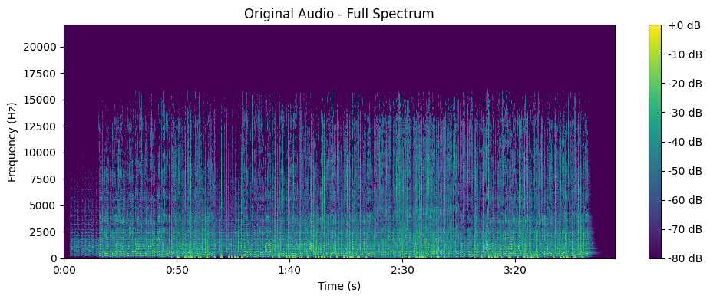
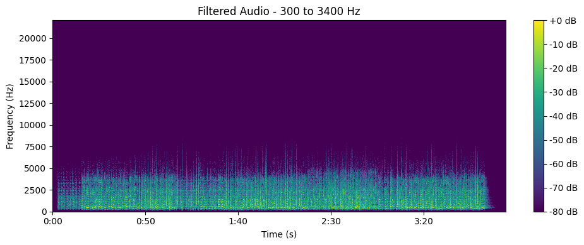

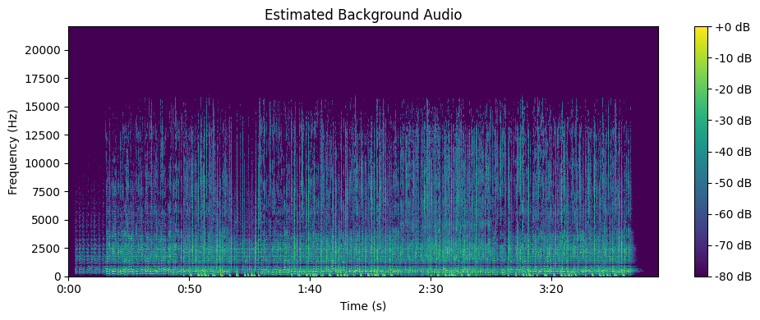
Conclusion for Q3(a): Low-Pass Filter :
The low-pass filter was applied to the original audio using three different cutoff frequencies. I observed that a lower cutoff frequency removes more high-frequency components, making the audio sound duller, while a higher cutoff frequency preserves more of the original sound. The waveform and frequency spectrum helped me understand how the filter changes the audio signal. Overall, this experiment showed how the cutoff frequency affects the clarity and tonal quality of music.

Conclusion for Q3(b): Band-Pass Filter :
The band-pass filter was used to keep a selected range of frequencies while reducing frequencies outside that range. I observed that changing the frequency range affects the sound quality and the amount of vocals and background music that can be heard. Although the filter can make certain parts of the audio more noticeable, it cannot completely separate vocals from background music. This experiment helped me understand how band-pass filtering can be used to analyze and modify audio signals.

